# CS 255 System Design Document Template

This template lays out all the different sections that you need to complete for Project Two. Each section has guidance to prompt your thinking. You will need to continually reference the interview transcript as you work to make sure that you are addressing your client’s needs. There is no required length for the final document. Instead the goal is to complete each section based on what your client’s needs are. Remove this note when you are finished, and replace all bracketed text with the relevant information.

## UML Diagrams

### UML Use Case Diagram

### UML Activity Diagrams

### UML Sequence Diagram

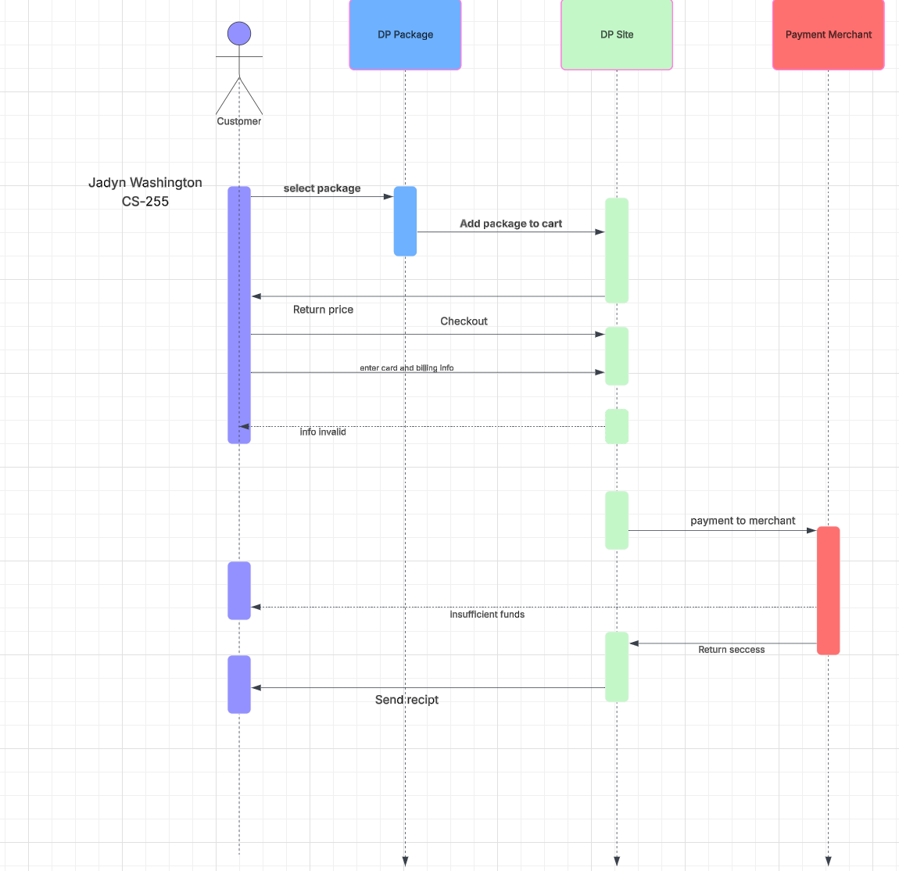

### UML Class Diagram

## Technical Requirements

*Hardware*

* *Dedicated Server*
* *Strong internet connection*
* *Database and website data storage*
* *Access to a computer or mobile device*

*Software*

* *Security software to prevent malware*
* *SQL server for database management*
* *Windows server*

*Environmental information*

* *Server should be in a median location*
* *Website should be accessible in America(branch out more in the future*
* *Website and database server should be in a protected data center*